**Ideation Phase**

**Brainstorm & Idea Prioritization Template**

|  |  |
| --- | --- |
| Date | 5 NOVEMBER 2022 |
| Team ID | PNT2022TMID13490 |
| Project Name | GAS LEAKAGE MONITORING AND ALERTING SYSTEM |
| Maximum Marks | 4 Marks |

**Brainstorm & Idea Prioritization Template:**

Brainstorming provides a free and open environment that encourages everyone within a team to participate in the creative thinking process that leads to problem solving. Prioritizing volume over value, out-of-the-box ideas are welcome and built upon, and all participants are encouraged to collaborate, helping each other develop a rich amount of creative solutions.

Use this template in your own brainstorming sessions so your team can unleash their imagination and start shaping concepts even **if you're not sitting in the same room.**

# Step-1: Team Gathering, Collaboration and Select the Problem Statement

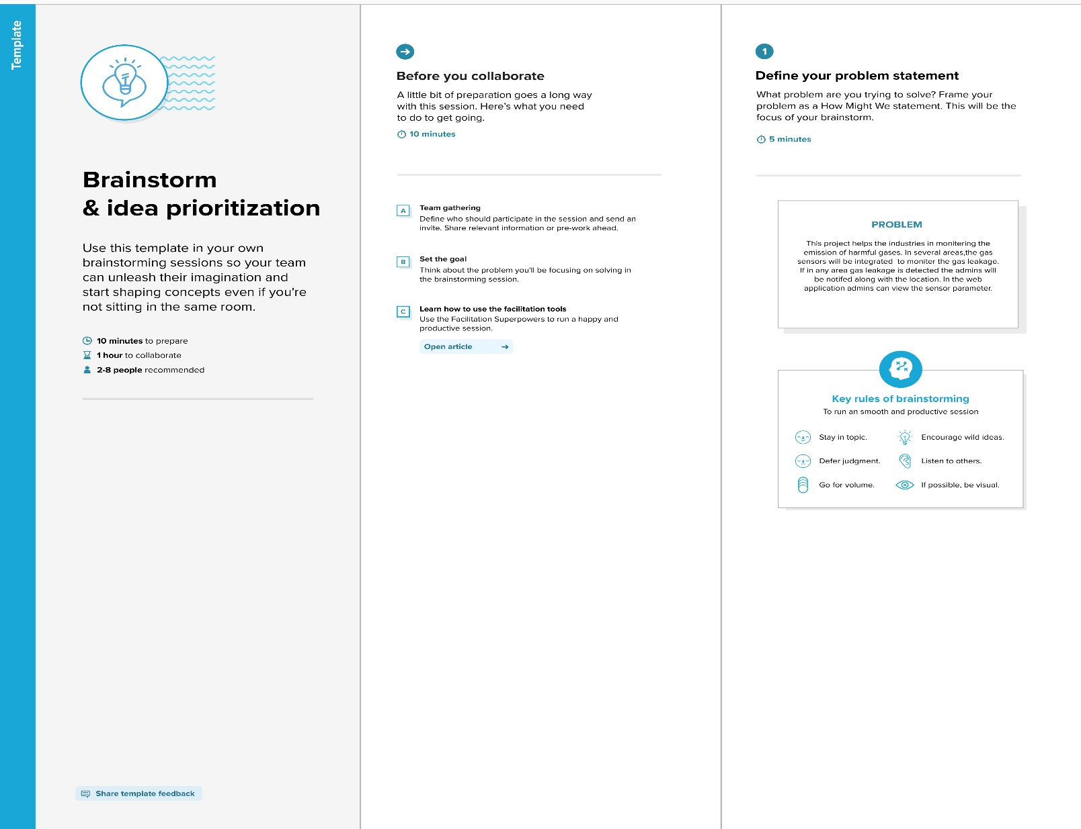

**Step-2: Brainstorm, Idea Listing and Grouping**

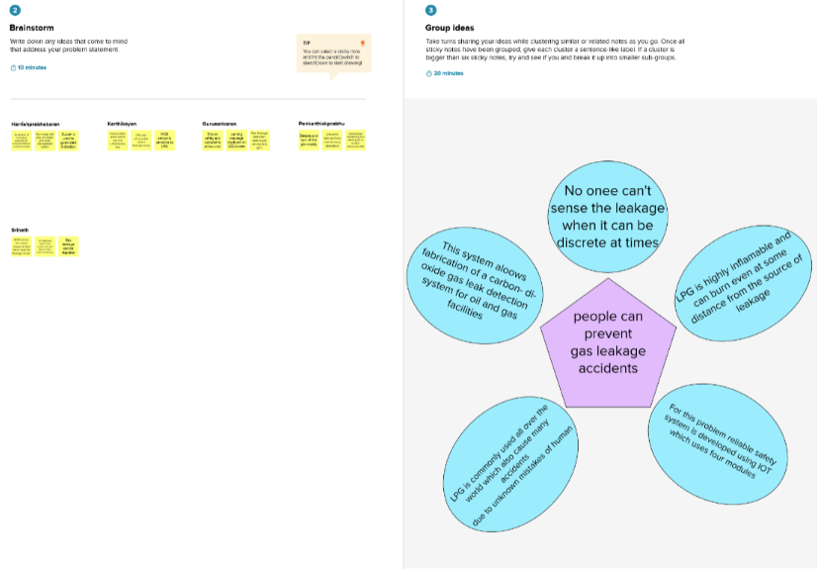

**Step-3: Idea Prioritization**

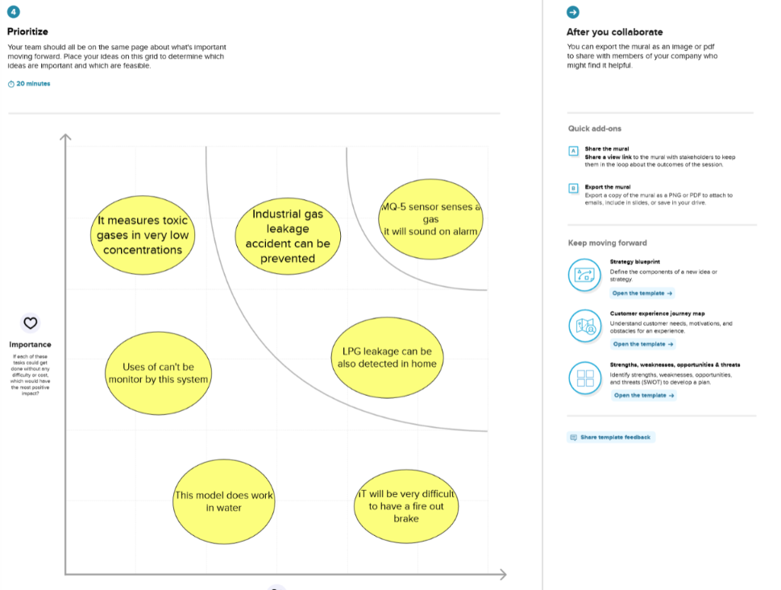

**Full Image:**

